Self-Orthotherapy program using Arduino and pressure sensor

Hakjun Kim

Information System in HYU Email: [canon3478@gmail.com](mailto:canon3478@gmail.com)

Minsoo Choi Information System in HYU Email: [choiza03@gmail.com](mailto:choiza03@gmail.com)

Group Name : ’Healpers’

Taejin Kim Information System in HYU Email: o [xo@naver.com](mailto:xo@naver.com)

***Abstract*—This project is about self-orthotherapy system using Arduino with a built-in bluetooth 4.0 communication chip and pressure sensor which communicates with an Android application. This program can definitely detect users’ incorrect postures and can be used for long-term postural analysis and correction as saving users’ postural data in database.**

***Keywords*—Self-orthotherapy, Arduino, Pressure sensor, Android application**

1. INTRODUCTION

In modern society, most office workers spend over 12 hours each day sitting on a chair. This immod- erate sedentary lifestyles and incorrect posture can cause many severe health problems. For instance, incorrect posture can lead to turtle neck syndrome, scoliosis, chronic low back pain, cervical disc and herniated disc. In particular, crossing legs can twist the pelvis which induces pelvis inflammation and may change the shape of spine and trigger crooked legs, all of which are the reason for an asymmetrical

body. In other words, correct posture will be the most effective way to prevent the above diseases.

Therefore, maintaining a good posture in a forced sedentary lifestyle has a great significance to keep them healthy. Nevertheless, when office workers concentrate on working or loosen the tension, pos- ture would be disturbed. So we would like to develop an application to help them correct their wrong postures.

|  |  |  |
| --- | --- | --- |
| Role Name Task description and etc. | | |
| User | Minsoo Choi | * Test the application in various postures. * Require bugs to be fixed. * Demand the all of data about user. * Require additional functions. |
| Software Developer | Taejin Kim | * Develop the application using Arduino and   pressure sensor.   * Fix bugs. * Develop additional functions according to users’ needs. |
| Development Manager | Hakjun Kim | * Monitor the progress of the project. * Make a overall plan about developing program and managing the budget * Reflect users’ needs |

The application can recognize the position by using Arduino and pressure sensor. The application will perform the correction of posture immediately by informing the users’ incorrect postures. This application is expected to greatly contribute to maintaining a healthy posture and lifestyle of the modern office workers.

1. REQUIREMENTS
2. *Required hardware and software*

-Arduino Uno R3 Board

-FSR 406(Pressure sensor)

-Connecting pin

-Bread Board

-HC 06(Bluetooth Module)

-USB cable

-Arduino Sketch(Using C)

-Android Studio(Using Java)

-MySQL

-pgAdmin(Using ProgreSQL)

1. *Requirements for Developers*
   * Making pressure recognizing cushion

First, we have to make proper pressure recognizing cushion to recognize users’ posture. So, we are going to make cushion with pressure sensors fitted to the chair’s size. Now, we have plan to use ’FSR 406(Pressure sensor)’ that the size is approximately 38mm x 38mm. So, we are going to make cushion with four(2x2) pressure sensors or more to recognize users’ posture properly.

* + Connecting pressure sensor with Arduino Board Second, we have to connect pressure sensor with Arduino Board to get pressure value. And we have plan to use ’Arduino Uno R3 board’. So, we are going to connect ’FSR pressure sensor’ with ’Arduino Uno R3 board’ and test whether we get proper pressure value when user changes the

posture.

* + Making orthotherapy algorithm using pressure value

If we succeeded in getting proper pressure value, we make our own orthotherapy algorithm. We will analyze pressure values and set cases to correct users’ posture. For example, when the right side’s pressure value is low we show alert message (”Your body is tilted to the left” or ”Don’t let your right leg crossed”).

* + Developing Front-end Android Application After we make orthotherapy algorithm we have

to develop android application. So, we will develop

the application according to our UI/UX and architecture design. We have two parts in our front- end application. The first is the Self-Orthotherapy part and the second is showing analyzed result using users’ personal data.

* + Constituting Database for saving users’ data We should design database tables for saving

users’ data. And we make sign-up form for user

to register in our application. And we get essential data such as ID, PW, Phone number and put it into the our database.

* + Developing Server to manage users’ data

We will provide analyzing service using users’ personal data. So, we have to manage users’ own Id and Password by server and save the users’ specific data. For example, if the user got some alert messages or moves out the users’ seat, we save that data and we will provide graph or chart by analyzing that data.

1. *Requirements for Users*
   * Getting alert message when having bad posture If user had bad posture, program recognizes that and shows the alert message to fix that posture. Bad posture means i) sit with one’s legs crossed.

ii) the waist is bended iii) the body is tilted to right or left too much.

– Approaching users’ personal data

User needs authority to approach to own personal data. So, user should sign-up for our application. After that, user could check own personal data any time. For instance, how many times the user sit with right leg crossed today or how long the user left the seat during the work concentration time.

1. *Requirements for Application*
   * Sign Up

This application uses the ID to the user by storing the time information of the server to be able to store and view the information, if not the own device. The user can easily sign up only your name, E-mail, if you ever forget your ID and Password can be easily found via E-mail.

* + Log In / Out

When running this application, user has to log-in in order to record the time sitting on the cushion on a server. But, to shorten the log-in procedure, user can log-in easily after log- in once because the information of ID and password is saved. If the User wants to log-out, user can logs out in the Setting Page.

* + Statistics

The application stores the users’ data on the server. The application stores the users’ data on the server. Then this application produces statistics

on a weekly, monthly, yearly. These statistics will help determine whether seeing how much work they have kept for themselves some attitude.

* + Data Visualization

User allows to easily identify their own data through the application using the data visualization. The application will use the visualization techniques, such as Android Chrono-meter, Chart, VideoView.

* + Guide to Good Posture

This application shows the right postures using some kind of videos and images and introduces stretching and exercises which are good to correct wrong posture.

* + Suggest to Rest

If user overworks, this application will show the message likewise ”Take a Break! Do strectch!”.

* + Push Alarm

If user keeps wrong posture over certain time, this application will warn to the user about that wrong posture by push alarm.

* + Customize Setting

User can set the status of getting push alarm(On/Off) and the time when the user gets push alarm while the user keeps wrong posture. And the user could use ”Initializing” function. ”Initializing” means the user’s own pressure values saved in the database (when user does ’normal’ posture) are initialized.

* + Provide Scores

Users can grasp how well they have sat for today as this application provides today’s posture score. Users can also check whether their postures are improving or not.

* + Body Balance Measurements

Users can measure their current body balance status by taking a photo of their upper body. If, users take picture by using this function, the program would offer the information about how much their body is twisted.

1. DEVELOPMENT ENVIRONMENT
2. *Choice of software development platform*
   1. Which platform and why?

* Windows for android application developing Our target is office workers who want to correct

their sitting posture. For ortho-therapy, it is the most important and efficient to maintain correct posture intentionally. Considering this, developing mobile application is appropriate rather than either web or computer program operated in window OS because time with mobile phone is longer than time using computer. If there is only our posture-correcting cushion, users can notice that they sit in incorrect posture by push alarm at anytime and anywhere, even while watching TV and reading a book at home. And this data is saved in server automatically so they can check the statistics how long they were sitting and how many times they sat incorrectly. Because Android OS is being used much more than IOS, as the below Figure 1 is showing, we develop our application in Android application.

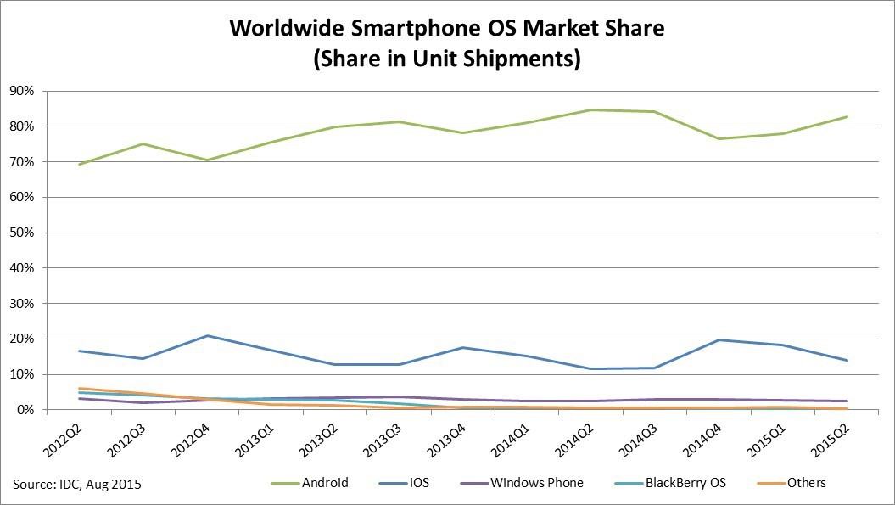

Fig. 1. Worldwide Smartphone OS Market Share

* 1. Which programming language and why?
* Java for android application developing

Java is a general-purpose computer programming language that is concurrent, class-based, object- oriented, and specifically designed to have as few implementation dependencies as possible. As of now, Java is one of the most popular programming languages in use, particularly for client-server web applications, with a reported 9 million developers. Java was originally developed by James Gosling at Sun Microsystems (which has since been acquired

by Oracle Corporation) and released in 1995 as a core component of Sun Microsystems’ Java platform. The language derives much of its syntax from C and C++, but it has fewer low-level facilities than either of them. And Java is the best suitable language to develop the application in android OS.

* C for IDE

We should do many tests to recognize various users’ postures using pressure values getting from FSR-406 pressure sensors. So, we use the open-source Arduino Software (IDE) and the best proper language to use this program is C. The open-source Arduino Software (IDE) makes it easy to write code and upload it to the board. It runs on Windows, Mac OS X, and Linux. The environment is written in Java and based on Processing and other open-source software. This software can be used with any Arduino board.

* PHP

PHP is a server-side scripting language designed for web development but also used as a general- purpose scripting language that is especially suited to web development. PHP is fast, flexible and pragmatic language. And PHP makes the user write dynamic web files because PHP follows many sentence forms used in C, Java, Perl etc. And there is excellent documentation we can refer to. <http://www.php.net/> has really good documentation with helpful user-contributed gotchas and code snippets. We can also find tons of tutorials, etc. around the web.

* 1. Provide a cost estimation for your built.
* Cost for Server :

1 year for free. And after 1 year, there will be additional prices. We predict maybe about 1,000 people will use our service, and DAU (Daily Activity User) will be 300 around. So we will use t1. micro instance (AWS), and its prices are about

30 dollars per month: So may be there will be additional 360 dollars per year.

– Cost for hardware

1. Arduino

The Uno is a microcontroller board based on the ATmega328P. It has 14 digital input/output pins (of which 6 can be used as PWM outputs), 6 analog inputs, a 16 MHz quartz crystal, a USB connection, a power jack, an ICSP header and a reset button. It contains everything needed to support the microcontroller; simply connect it to a computer with a USB cable or power it with a AC-to-DC adapter or battery to get started. The Uno board and version 1.0 of Arduino Software (IDE) were the reference versions of Arduino, now evolved to newer releases. The Uno board is the first in a series of USB Arduino boards, and the reference model for the Arduino platform; for an extensive list of current, past or outdated boards see the Arduino index of boards.

1. Pressure Sensors

The model 406 FSR is a single-zone Force Sensing Resistor optimized for use in human touch control of electronic devices such as automotive electronics, medical systems, and in industrial and robotics applications. FSRs are two-wire devices. They are robust polymer thick film (PTF) sensors that exhibit a decrease in resistance with increase in force applied to the surface of the sensor. It has a 39.6mm square active area and is available in 4 connection options. Interlink Electronics FSR 400 series is part of the single zone Force Sensing Resistor family.

1. Bluetooth Module

HC-06 is a serial port module composed in SMD form which is possible to be replaced easily. It also uses the connection between the bluetooth Master module in either PC or mobile device and embedded system in substitution of the serial port.

Arduino receives the input values, which the four pressure sensors perceive, through the breadboard and sends those values to the Android Application via bluetooth communication with the mobile phone. The system flow is shown in Figure 2.

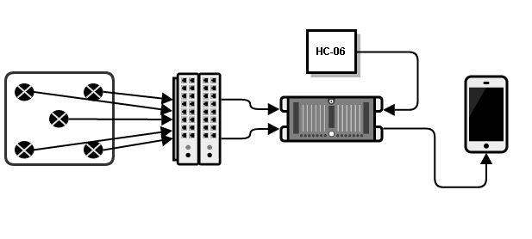

Fig. 2. System Flow

Therefore, we need 4 pressure sensors, Arduino, bluetooth module, bread board, USB cable and jump wire MM. The specific products’ cost is shown in Table 1.

TABLE I

THE SPECIFIC PRODUCTS’ COST

|  |  |  |  |
| --- | --- | --- | --- |
| Products Prices Quantities Costs | | | |
| Pressure Sensor (FSR-406) | 14,000 | 4 | 56,000 |
| Arduino Uno (R3) | 7,500 | 1 | 7,500 |
| Bluetooth Module (HC-06) | 6,000 | 1 | 6,000 |
| Bread Board | 4,500 | 1 | 4,500 |
| USB Cable | 500 | 1 | 500 |
| Jump Wire MM | 70 | 50 | 3500 |
| Total | | | 78,000 |

* 1. Provide clear information of your development environment. (e.g., version of software, OS version, your computer resources)
* Android develop

1. Windows : Windows 10
2. Android Studio 1.5.1 / Android 4.4.4 Kitkat

* Arduino develop

1. Windows : Windows 10
2. Arduino 1.6.8 (IDE)
   1. Using any commercial cloud platform (e.g., Amazons EC2) is definitely a BONUS.

1) Amazon Web Server

We will use Apache Web Server because it is the world’s most widely used web server software. As of June 2013, Apache was estimated to serve

* 1. percent of all active website and 53.3 percent of the top servers across all domains. (The most important reason is we have already apache web server.)

Apache Web Server has some features:

* + - easy and fast customizing using module.
    - It can handle many traffic easily.
    - It can control web server more delicately
    - It is tested enough, so it is very stable.

2) Google Clould Messaging (GCM)

We use Google Cloud Messaging for using push alarm function. Because getting push alarm is important function in our application. Users could recognize whether their sitting posture is right or wrong by push message.

Google Cloud Messaging (commonly referred to as GCM) is a mobile service developed by Google that enables third-party application developers to send notification data or information from developer-run servers to applications that target the Google Android Operating System, as well as applications or extensions developed for the Google Chrome internet browser. The GCM Service was first announced in August 2013 as a successor to Google's now-defunct Android Cloud to Device Messaging (C2DM) service, citing improvements to authentication and delivery, new API endpoints and messaging parameters, and the removal of limitations on API send-rates and message sizes.

1. *Software in use*

* Footlogger

3L-Labs, internal venture corporation, developed a smart wearable device ’FootLogger’. It is insoles with some pressure sensors which analyze users’ steps. This device can be used for health care, sports and entertainment.

Healthcare

* Monitors recovery after surgery
* Assesses balance of diabetics
* Allows for monitoring of prescribed exercises
* Monitors safety and activity of senior citizens
* Activity tracking (calories, distance, time)
* Early prediction of dementia and spinal disease
* Early prediction of accidents from falling
* Monitors rehabilitation (stroke, paralysis)

Sports

* Can monitor distance traveled
* Monitors golf stance and gives coaching
* Marathon/jogging aid
* Out-toeing/in-toeing gait identification, provides gait coaching
* Kids’ correct posture coaching
* Can be applied to every sport

Entertainment

* Daily log (standing, sitting, walking)
* Personality analysis
* Daily mood analysis
* Smartphone game input device

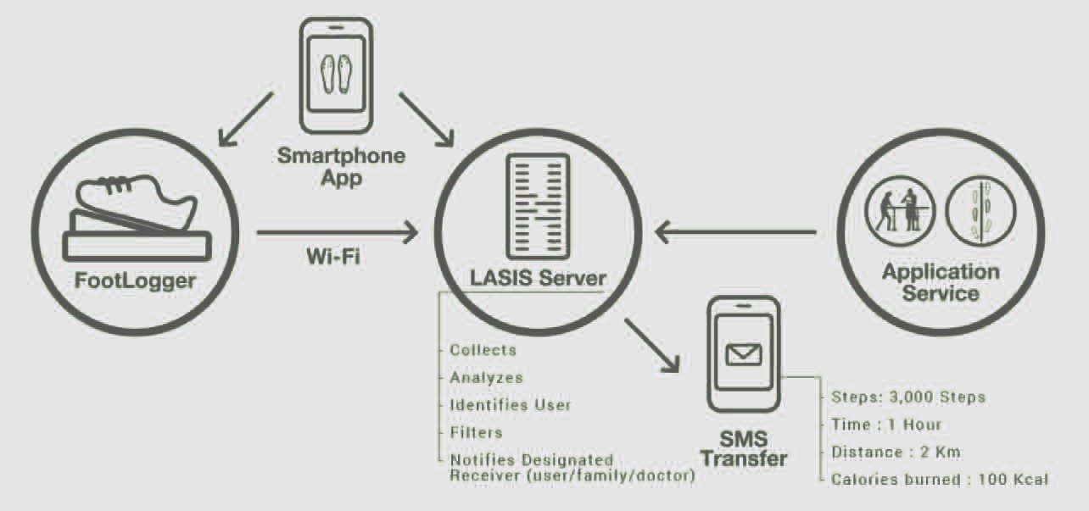sent to server, and saved at server. At the same time, the application will receive the user’s whole data from server. Then, the application will display the data by data visualization.

1. *Task distribution*

Fig. 3. Footlogger

TABLE II

TASK DISTRIBUTION

|  |  |  |
| --- | --- | --- |
| Role Name Task description and etc. | | |
| User | Minsoo Choi | * Test the application in various postures. * Require bugs to be fixed. * Demand the all of data about user. * Require additional functions. |
| Software Developer | Taejin Kim | * Develop the application using Arduino and   pressure sensor.   * Fix bugs. * Develop additional functions according to users’ needs. |
| Development Manager | Hakjun Kim | * Monitor the progress of the project. * Make a overall plan about developing program and managing the budget * Reflect users’ needs |

*B. Posture Recognition using pressure sensor*

We made a kind of cushion for measuring pressure force. The dimensions of the chair and cushion are shown in Table 3. And we used FSR- 406 pressure sensor model to get proper pressure value for recognizing person’s changing posture. The dimensions of FSR-406 are shown in Figure 5.

TABLE III

DIMENSIONS OF THE CHAIR AND CUSHION

1. SPECIFICATIONS

*A. Modeling for Specifications*

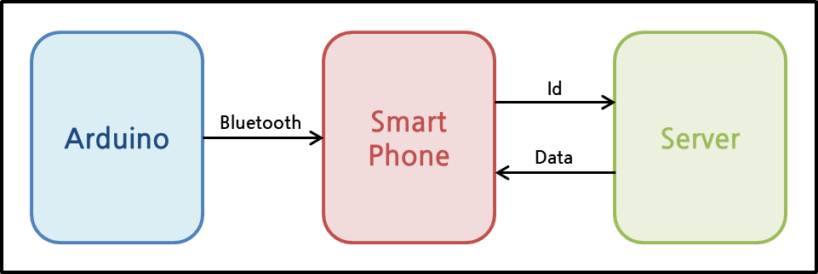

Fig. 4. Basic structure

Arduino receives some of the pressure value from the pressure sensor. And arduino sends the values to smart phone using HC-06. HC-06 is a Bluetooth Module. Then smart phone application determines posture of the user by analyzing the values. After that, smart phone calculates the time for holding the posture. The data of time will be

|  |  |
| --- | --- |
| Width of the chair | 45cm |
| Height of the chair | 42cm |
| Depth of the chair | 47cm |
| Width of the cushion | 30cm |
| Height of the cushion | 30cm |

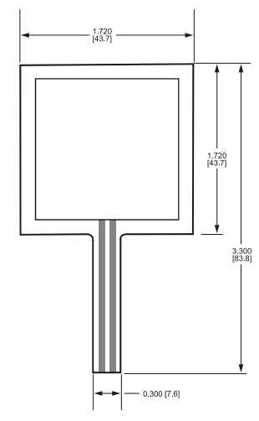

Fig. 5. Dimensions of FSR-406

The reason why we choose the FSR-406 is the specifications of FSR-406 are suitable to make the posture recognition cushion. This sensor is very thin and hence can be easily bent to fit, so a user can sit down on the seat comfortably. Since the sensor sheet

is light and thin, it can be carried anywhere and used in various situations in daily life. And the active area is appropriate to get pressure value when person changes his or her posture. FSR-406 specifications are shown in Table 4.

TABLE IV

FSR-406 SPECIFICATIONS

|  |  |
| --- | --- |
| Thickness | 0.018” (0.46 mm) |
| Active area | 38.1mm *x* 38.1mm |
| Connector | AMP Female connector |
| Minimum load | 0.1N |
| Maximum load | 10N |

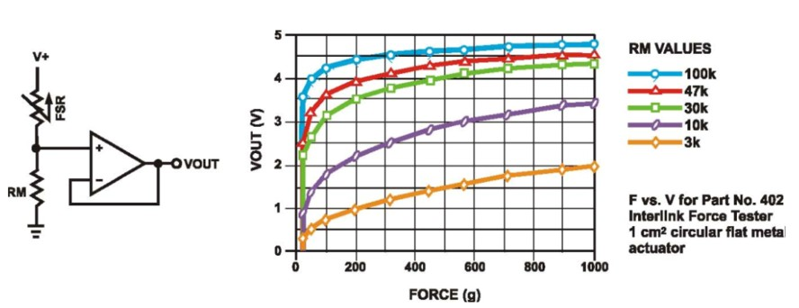

Fig. 6. Typical Schematic and force curve of FSR-406

TABLE V

THE CLASSIFICATION OF PRESSURE SENSOR’S POSITION

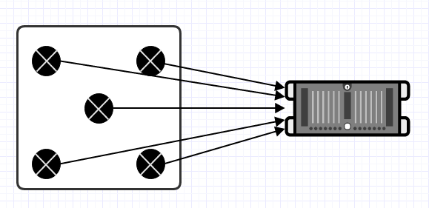FSRs are two-wire devices with a resistance that depends on applied force. For specific application needs please contact Interlink Electronics support team. An integration guide is also available. For a simple force-to-voltage conversion, the FSR device is tied to a measuring resistor in a voltage divider configuration. The output is described by the equa- tion:

|  |  |
| --- | --- |
| (LF) | Left Front |
| (RF) | Right Front |
| (C) | Center |
| (LB) | Left Back |
| (RB) | Right Back |

V*out* = (*R*

*RmV* +

+ *R* )

*M FSR*

In the shown configuration, the output voltage increases with increasing force. If *RFSR* and *RM* are swapped, the output swing will decrease with increasing force. These two output forms are mir- ror images about the line *Vout* = (*V* +)*/*2. The measuring resistor, *RMr* is chosen to maximize the desired force sensitivity range and to limit current. Depending on the impedance requirements of the measuring circuit, the voltage divider could be fol- lowed by an on-amp. A family of FORCE vs. *Vout* curves is shown on the graph above for a standard FSR in a voltage divider configuration with various *RM* resistors. A (*V* +) of +5*V* was used for these examples.

To recognize difference of sitting posture, we have to make the cushion with proper number of pressure sensors. So, we arranged five pressure sensors to the five points in the cushion. The five points are ’Left- front’, ’Right-front’, ’Center’, ’Left-back’, ’Right- back’ and this classification is shown in Table 5. And the pressure values are transmitted to Arduino board through bread board. The pressure sensors’ spot position is shown in Figure 7.

Fig. 7. Pressure sensors’ spot position

1. *Posture classification*

In this part, we describe a way of classifying sitting postures. Posture classification involves three basic issues. One issue is person dependency. Dif- ferent persons would obviously sit in different ways. Even the same person might sit on different parts of the seating face. One ways to resolve this problem is to normalize pressure distributions by standardizing different postures when workers sit in the chair. The classification of seven postures is shown in Table 6. Second issue is the time dependency. We have to push alarm to users when they are doing wrong postures. So, it is needed to decide when we do alarm function. We set time standard from 1 minute to 10 minutes. User could select time when user gets push alarms while user keeps wrong posture. And the last issue is weight dependency. The sensor values would increase linearly or non-linearly with

TABLE VI

THE CLASSIFICATION OF SEVEN POSTURES

|  |  |
| --- | --- |
| (N) | Left Front |
| (F) | Leaning Forward |
| (B) | Leaning Backward |
| (L) | Leaning Left |
| (LC) | Left leg crossed |
| (R) | Leaning Right |
| (RC) | Right leg crossed |

an increase in weight. Therefore, it would be effec- tive to divide the sensor values by the total value. And the each user’s pressure value is different when user does ’Normal’ posture. So, if user registers in our application, the user’s initial pressure values are saved in the database and our algorithm uses each user’s data to recognize posture. And we offer the function which initializes user’s weight in the application.

1. *Specification for Bluetooth communication*

We use Arduino board and bluetooth module to get pressure values in the application and do wire- less communication. There are many ways doing wireless communication with Arduino such as Wifi, XBee, Bluetooth etc. But Wifi wastes electronic power consuming too much and the connection status is sometimes not stable. And XBee is not widely used because smart phone and pc should have XBee module. On the other hand, Bluetooth module is cheaper than Wifi module and is widely used compared to Xbee because most of the smart phone and pc could recognize bluetooth module. And we use ’Arduino Uno R3’ and ’HC-06’ because ’Arduino Uno R3’ is the basic platform among arduino series and ’HC-06’ bluetooth module has excellent performance compared with other blue- tooth modules and both of them have very good cost-effectiveness. And bluetooth sets the link with ’Master’ and ’Slave’ way. If mobile application communicates with arduino bluetooth, the smart phone becomes ’Master’ and Arduino becomes ’Slave’. So, we connect HC-06 with Arduino Uno R3, this is shown in Figure 8.

The ’Blue’ line is connection RX pin of HC- 06 with digital I/O number 2 of Arduino (RX pin gets some signal from Arduino). The ’Green’ line is connection TX pin of HC-06 with digital I/O

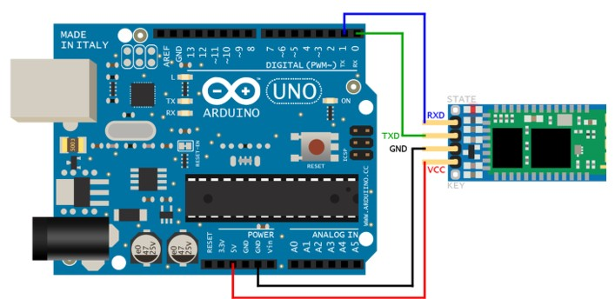

Fig. 8. Connection of arduino with bluetooth module

number 3 of Arduino (TX pin transmits some signal from bluetooth). The ’Black’ line is connection GND pin of HC-06 with GND of Arduino (GND is a voltage emitter). The ’Red’ line is connection VCC pin of HC-06 with 5V of Arduino (VCC is a votage collector).

And we set HC-06’s options to test status of connection with bluetooth and pc. The sample option values of HC-06 are shown in below box.

1. Test Instruction word: AT Return Value: OK
2. Version Checking Instruction word: AT+VERSION Return Value: OKlinvorV1.8
3. Name Change Instruction word: AT+NAME Return Value : OKsetname
4. Baud rate Setting Instruction word: AT+BAUD(Baud rate menu value). Baud rate menu: 1 - 1200, 2 - 2400, 3 - 4800, 4 - 9600 5 - 19200, 6 - 38400, 7 - 57600, 8 - 115200 Return Value : OK Baud rate (ex : OK9600)
5. PIN Setting Instruction word: AT+PIN(4 digits). Return Value : OKsetPIN
6. *Specification for front-end application pages*

– Log-In Page

This page is the first page of the application. To import the posture data, you have to log in first. Your working posture records will be saved in your server with your ID. If you do not have an ID,

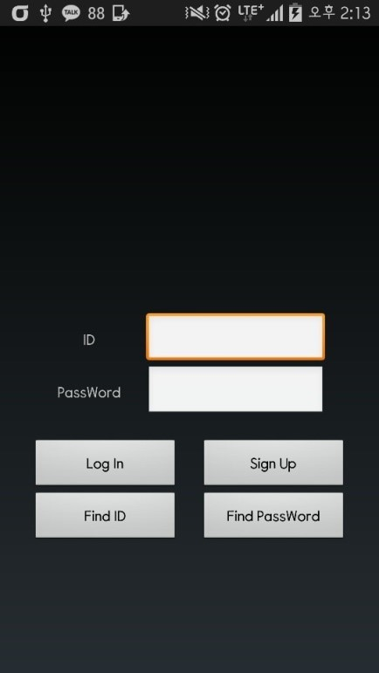 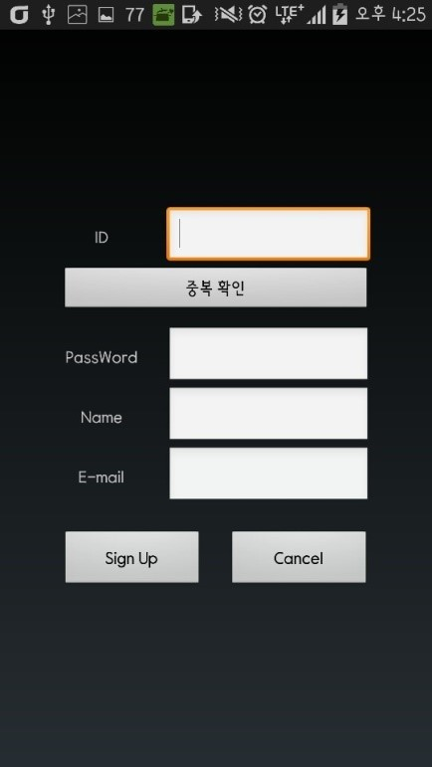

Fig. 9. Log-In Page

you can click the Sing Up button. Or, if you forgot your ID or password, you can find it using Find ID button or Find Password button. Once you log in, your ID and password will be automatically saved. Even when you log in via another phone, you can open your records with ease since your posture records are imported from your ID only.

* Sign-Up Page

This page is where a user with no ID can create a new ID. Since ID will be the Primary Key of the User DB that will be saved in the server, it should not be overlapped. So, it is mandatory for you to double-check your ID. There is no limit in the length of the password and the password will be replaced with other letters, such as ****, as soon as you enter your password for the sake of absolute confidentiality.

Name and E-mail will be used for discerning between members and non-members. And, they will also be used for finding ID or Password in case you forgot it.

* Find ID Page

Fig. 10. Sign-Up Page

Once you enter your E-mail that you entered during Sign-up process, it tells your ID on the screen.

–Find Password Page

Once you enter your E-mail that you entered during Sign-up process, it sends your password to your E-mail.

–Now Page

This page is the first page you see after you log in. There are 4 tabs in the tab bar below. ’Now’ tab is the tab of the current page. If you click the ’Stat’ tab, you can check your accumulated statistics on daily, weekly, monthly and yearly basis. ’Tip’ tab is where you can find images and videos of stretches or exercises useful for correcting posture. The last ’Setting’ tab is for setting few functions related to this application.

In this page, the app counts the number of hours you sit on the cushion that is composed of pressure sensor. This data will be exported on the screen in order for you to check your total working hour. (Upper Timer)

In specific, it counts the number of hours of your

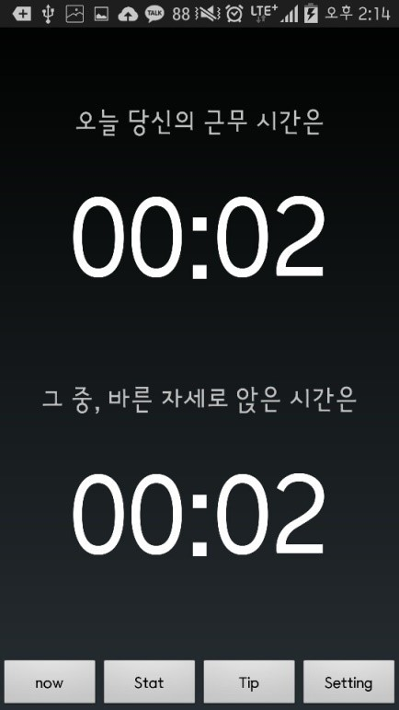 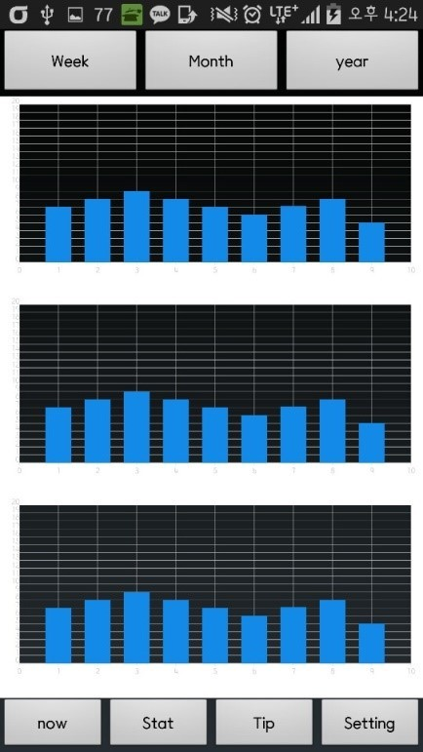

Fig. 11. Now Page

correct posture and bad posture separately. So, it is possible to check the number of hours of correct posture only. (Lower Timer)

The number of hours exported from this page will be saved in the server as well. Moreover, once the user maintains a bad posture for a long time, the user will receive a push notification that warns his/her long-time bad posture.

–Stat Page

This page shows up as you click the Stat tab below. It is divided into 3 big graphs and has three tabs at the top of the screen. The graphs of this page are composed of individual time data saved in the server. Each of the three graphs represents total working hour, the number of hours of correct posture and the bad posture. The x-axis of this graph changes according to the upper tab of the screen. The x-axis consists of 7 days in the ’Weekly’ tab, 30 days in the ’Monthly’ tab and 12 months in the ’Yearly’ tab. The y-axis of every tab consists of numbers from 0 to 24, which refer to the number of hours.

The first graph will be presented as a Bar Chart that shows working hour of the days of the week in the ’Weekly’ tab, daily working hour in the

Fig. 12. Stat Page

’Monthly’ tab and monthly average working hour in the ’Yearly’ tab. With the same principle, the second graph shows the number of hours of correct posture for each tab whereas the third graph shows the number of hours of the bad posture.

And user could see the score measuring by this program. The score means how well users have sat for today. The score is from 0 to 100 and 100 is the maximum score which means the users posture for today is perfect.

–Tip Page

When clicking the Tip tab below this page, this page will show up. It exports images and videos of stretches or exercises useful for correcting posture as a customized ListView. The function of playing or pausing the video takes the similar format with Youtube. The first click plays the video and the second pauses it.

–Setting Page

This page shows up when you click the ’Setting’ tab below this page. The first function of this page, comprised of a ListView, is switching on or off the push notification. Essentially, if the user maintains a bad posture for a long time, the user will receive

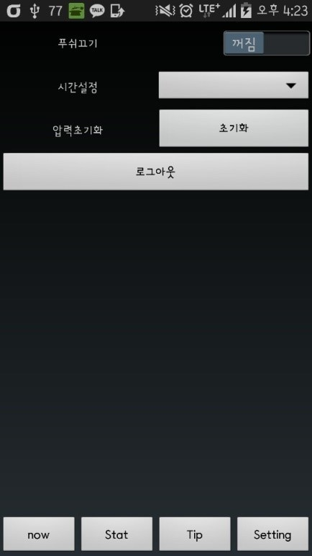Fig. 13. Tip Page

Fig. 14. Setting Page

a push notification that warns his/her long-time bad posture. This function can be controlled by the user. The second function is to set the time when user gets push alarms while user keeps wrong posture. It ranges from minimum 1 minute to maximum 10 minutes. For example, if you set your time to 2 minutes and you maintain a bad posture for 2

minutes, you will directly receive a notification.

The third function resets the pressure value that matches the users’ body. According to individuals’ weight and environment, the pressure value differs. Hence, it is necessary to save individuals’ initial pressure value of the correct posture in the server. The last but not least function is log-out. It allows the user to log out from the app.

– Body Balance Page In this page users could take picture of their upper body sitting on the chair. And the program analyses the users body balance by comparing left and right location of shoulder, chest and waist. Then the program shows how much the users body is twisted using degree. For example if the user’s left shoulder is tilted to the left about 30 degrees, the user could see the status of the body balance by green and red line(Green line is criteria line meaning good body balance and the Red line shows how much the body is tilted.)and the message like ”Your left shoulder is tilted to the left about 30 degrees” is shown.

1. ARCHITECTURE DESIGN AND IMPLEMENTATION
   1. *Overall architecture*

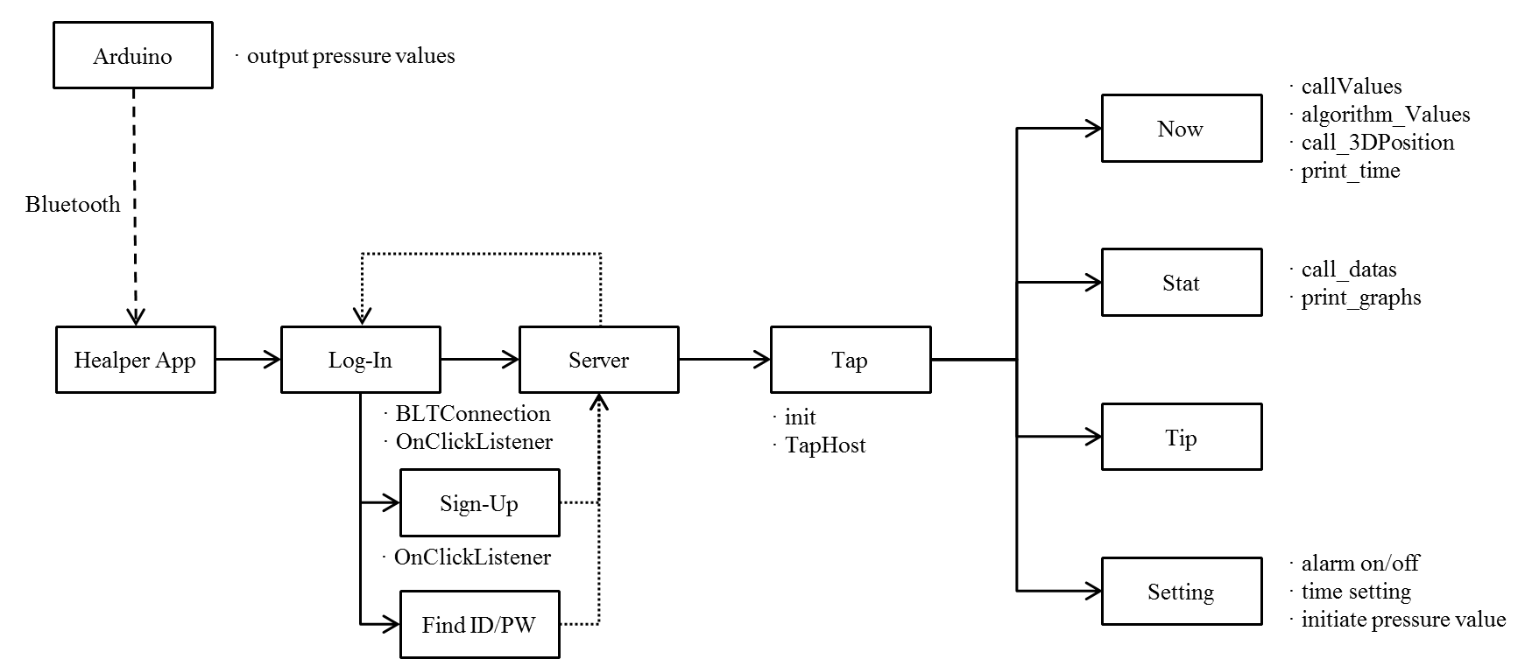

Fig. 15. overall architecture

* 1. *Directory organization*

Dir 1:

Healper_Proto/app/src/main/java/ com/example/lg/healper_proto

Dir 2: Healper_Proto/app/src/main/res/ layout

TABLE VII

DIRECTORY ORGANIZATION

|  |  |  |  |
| --- | --- | --- | --- |
| Directory File names Module name in use Etc | | | |
| Dir1 | MainActivity.java | MainActivity class |  |
| Dir1 | NowActivity.java | NowAcivity class |  |
| Dir1 | SettingActivity.java | SettingActivity class |  |
| Dir1 | SignUpActivity.java | SignUpActivity class |  |
| Dir1 | StatActivity.java | StatActivity class |  |
| Dir1 | TapActivity.java | StatActivity class |  |
| Dir1 | TipActivity.java | TipActivity class |  |
| In Arduino | ValuesToApp.ino | setup, loop method |  |
| Dir2 | main sub.xml |  |  |
| Dir2 | now sub.xml |  |  |
| Dir2 | setting sub.xml |  |  |
| Dir2 | signup sub.xml |  |  |
| Dir2 | stat sub.xml |  |  |
| Dir2 | tap sub.xml |  |  |
| Dir2 | tip sub.xml |  |  |

* 1. *Code analysis*
     1. ValuesToApp.ino
* Purpose:

To send the pressure value that Arduino receive from the pressure sensor to the application through bluetooth,

* Functionality:

This code is embedded in the Arduino. The pressure sensor accepts the pressure value every second, and the pressure value is sent to the application through bluetooth.

* Location of source code: In Arduino
* Class components:
  + - 1. Setup method

Setup method is used firstly when the Arduino is executed. In this program, the speeds of serial communication and bluetooth communication are established in setup method. Variables and Pin value

that is connected with the pressure sensors are declared and established.

* + - 1. Loop method

Loop method is used constantly while the Arduino is executed. In this program, the functions receiving and sending the pressure value are established in loop method.

* + 1. MainActivity
* Purpose:

To show main page and before the program is used in earnest, to set fundamental environment.

* Functionality:

This program uses ID and password functions to save each user’s individual data. For this, MainActivity provides log-in function that each users can log-in as their ID, sign-up function for users who start to use, find ID/password function for users who have forgotten theirs and bluetooth function for interworking specific cushion.

* Location of source code:

Healper_Proto/app/src/main/java/ com/example/lg/healper_proto/ MainActivity.java

* Class components:
  + - 1. BLTConnection method

Relationship between the pressure sensors and smartphone is necessary because this program re- ceives users posture data from the pressure sen- sor. In onClick method, BLTConnection method performs on/off functions and searching/connecting devices functions of bluetooth. Therefore, BLTCon- nection method is necessary in the first page, that is to say Log-In Page.

* + - 1. OnClickListener

There are four OnClickListner in MainActivity.

1. Log ()In

When users enter their ID and password and click Log-in Button, if the account is signed up for server, loading data that are associated with the account from server synchronize with moving to TapActivity. Unless the account is signed up for server, Sign-Up Page appears.

1. Sign ()Up

Users who start to use this program use Sign-up button to sign up. When this button is clicked, Sign- Up Page appears.

1. Find ID/ Find Password

When users have forgotten their ID or password, Find ID/Find Password button is used to move to Find ID/Password Page.

* + 1. SignUpActivity
* Purpose:

To show Sign-Up Page to users who start to use this program. Users can sign-up in Sign-Up Page.

* Functionality:

This activity saves new users’ accounts information. In this activity, therefore, ID that is going to be the primary key goes through the duplication check and individual account information are saved in server.

* Location of source code:

Healper_Proto/app/src/main/java/ com/example/lg/healper_proto/ SignUpActivity.java

* Class components:
  + - 1. OnClickListener

There are three OnClickListner in SignUpActiv- ity.

1. Redundancy ()Check

Individual account information reported in this page is going to be saved in server. Each user’s ID is going to be the primary key in server database. Therefore, the duplication check is necessary to check if an entered ID that tries to sign-up is same as other existing users’ ID. There are duplication check button for this.

1. Sign ()Up

Account information entered by users is saved in server and moves back to Log-In Page again.

1. Cancel

Cancel Sign-Up process moves back to Log-In Page again.

* + 1. TapActivity
* Purpose:

To show tap page and constitute tap view which consist of Now, Stat, Tip, and Setting for customer.

* Functionality:

TapActivity is the body of this program. We build this program to make users be able to transfer freely using ’tab’ from a tap to another tap among four taps; now status, statistics, tips and setting page. TapActivity is used in this part to make Fragment Activity showing each page as fragment.

* Location of source code:

Healper_Proto/app/src/main/java/ com/example/lg/healper_proto/ TapActivity.java

* Class components:
  + - 1. Init method

Init method in onCreate method, when this page is created, initialize all of taps to interwork each other.

* + - 1. TapHost

when four taps at the bottom of the page are clicked, Fragment is changed to an activity corresponding the tap. Switching page is convenient by using taps.

* + 1. NowActivity
* Purpose:

NowActivity shows users’ current posture. It helps users grasp what posture and how long they have adopted.

* Functionality:

NowActivity analyzes the pressure value that comes from Auduino through bluetooth. It also helps users see their current postures in 3D and shows how long the users have adopted the postures and how long they have sat by using chronometer

function.

* Location of source code:

Healper_Proto/app/src/main/java/ com/example/lg/healper_proto/ NowActivity.java

* Class components:
  + - 1. callValues method

callValues method in onCreateView saves the pressure values that are sent from Arduino through bluetooth in variables to input those values in algo- rithm ()Values.

* + - 1. algorithm ()Values method

Using the pressure values saved in variables by callValues method, it outputs the anatomy-computed current posture by input the variables in designed algorithm for analogizing the current posture.

* + - 1. call ()3Dposition method

call ()3Dposition method invokes 3D ()Position Graphic file corresponding current posture that is computed by algorithm ()Values and displays it in Now Page.

* + - 1. print ()time method

print ()time method displays users’ total sitting time and the time users have adopted their current postures in Now Page.

* + 1. StatActivity

–Purpose:

StatActivity makes statistical charts of users’ posture data in server and displays three graphs arranged by the week, the month and the year.

* Functionality:

StatActivity loads users’ data from server, makes statistical charts and by three graphs, helps users grasp their posture tendencies that they have adopted.

* Location of source code:

Healper_Proto/app/src/main/java/ com/example/lg/healper_proto/ StatActivity.java

* Class components:
  + - 1. call ()data method

call ()data method in onCreateView loads a recent year’s data of users from server. That loaded data is saved in time ()array.

* + - 1. print ()graphs method

Using data that is saved in variables through call ()datas method data, makes graphs and displays them in Stat Page.

* + 1. TipActivity
* Purpose:

To select and recommend orthotherapy videos that users probably need mostly after analyzing their postures.

* Functionality:

StatActivity analyzes today’s posture statistics and recommend the orthotherapy exercise for the particularly bad posture in priority. On the basis of data of server, furthermore, it recommends two or three exercises for the steadily bad postures.

* Location of source code:

Healper_Proto/app/src/main/java/ com/example/lg/healper_proto/ TipActivity.java

* Class components
  + 1. SettingActivity
* Purpose:

To configure software setting and hardware setting to suit users’ individual conditions.

* Functionality:

This program basically lets users know that they are maintaining bad posture by push alarm. However, it also has function that turns on/off push alarm function for the case that users do not want to be disturbed by push alarm. Or users can configure schedule time when they want to be alarmed. Because every user has different weights and balances, in addition, we added reset function

in Setting Page in case of that basic pressure value of postures might need to be configured newly.

* Location of source code:

Healper_Proto/app/src/main/java/ com/example/lg/healper_proto/ SettingActivity.java

–Class components:

* + - 1. alarm on/off method

There is a on/off switch for the push alarm in Setting Page. As we established on/off function in onClickListener of this switch, users can choose whether they turn on the push alarm or not.

* + - 1. time setting method

There is a list box in Setting Page. In this list box, there are ten options; from 1 minute to 10 minutes. After that time user selects, push alarm informs that users are maintaining the bad postures.

* + - 1. initiate pressure value method

Setting up a common pressure value is impossible since every users have different pressure values. Therefore, we made it possible that every users configure their own pressures value. When initialization button in Setting Page is clicked, the average pressure value that has input for five seconds is saved in application and also in server. This program judges whether users’ current postures are wrong or not comparing with the saved values.

1. USE CASES

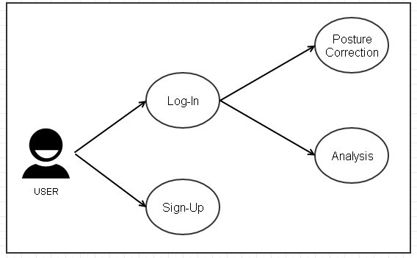

Fig. 16. Overall Usecase

The overall usecase is shown in the Figure 16. Our project’s platform is Android-Mobile Application. So, first user should download our application and execute the program to do self-orthotherapy. And if user executed the program, a dialog window to get permission of bluetooth and connect with Arduino would pop up. Then user will find the proper device and connect with the Arduino and finally could see the first page of our application. After that if user has registered already, user could enter into the next functions like ’Posture Correction’ or ’Analysis’. If not, user should sign-up and register user’s data into the program’s database to use this program.

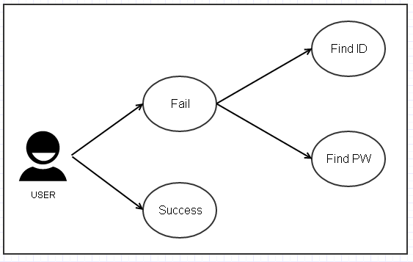

Fig. 17. Log-In Usecase

To use self-orthotherapy program, user should log-in to our system. But if user fails to do log- in, there are two ways of solving this problem. These are ’Find ID’ and ’Find PW’. Log-In Usecase is shown in the Figure 17 and the Use Case’s descriptions are written in the table 8.

TABLE VIII

THE DESCRIPTION OF LOG-IN USECASE

|  |  |
| --- | --- |
| Use Case | Description |
| Find ID | There are two ways to solve log-in problem. The first is ’Find ID’. User could find the own ID by writing the name and E-mail compared to the database’s data. |
| Find PW | And the second is ’Find PW’. User could find the own password by writing the ID, and name compared to the database’s data. It could meet the need of ’Log-In’ requirement. |

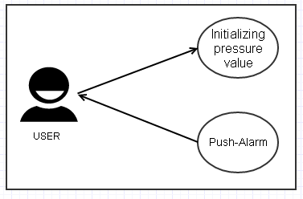

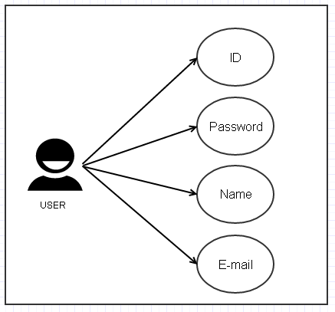Fig. 18. Sign-up Usecase

If user had not registered in our program, user should do sign-up to use the program. There are four componentes to register user’s data into the database. It could meet the need of ’Sign-Up’ re- quirement. Sign-Up Usecase is shown in the Figure 18 and the Use Case’s descriptions are written in the table 9.

TABLE IX

THE DESCRIPTION OF SIGN-UP USECASE

|  |  |
| --- | --- |
| Use Case | Description |
| ID | User should make unique ID to sign-up. It should be made of english and numbers under 10 characters. The special letters can not be used to make ID.And, it is mandatory for you to double-check your ID. |
| Password | There is no limit in the length of the password and the password will be replaced with other letters, such as  ****, as soon as you enter your password for the sake of absolute confidentiality. |
| Name | User should write own full name(first name + last name). And the english only could be used. |
| E-mail | User should write one e-mail address. User could select the portal’s address like ’gmail.com’ or ’naver.com’ or write the address in person. After that the permission  e-mail will be sent to the written e-mail address. So, it is not possible to do sign-up unless the user do not check the permission e-mail. |

Fig. 19. Posture Correction Usecase

they keep bad posture. Posture Correction Usecase is shown in the Figure 19 and the Use Case’s descriptions are written in the table 10.

TABLE X

THE DESCRIPTION OF POSTURE CORRECTION USECASE

The main function of this program is to correct user’s bad posture when user sits down on the chair. So, setting the user’s own pressure value is mendatory. Because people have different physical size and weight. Initializing pressure value is the function to meet that requirement. After initializing pressure value, user could get alarm message when

|  |  |
| --- | --- |
| Use Case | Description |
| Initializing Pressure Value | To get posture correction alarm, initializing pressure value is needed. Because our algorithm needs the fixed pressure value suited to the user. So, average of 5 times pressure values(when user sit down to the cushion, the pressure values are recognized.)is selected as the initial pressure value of user. |
| Push-Alarm | If user has wrong posture, program would recognize that status using posture correction algorithm. And the push alarm will be popped up to the user’s mobile phone like ”Do not make your leg crossed”. |

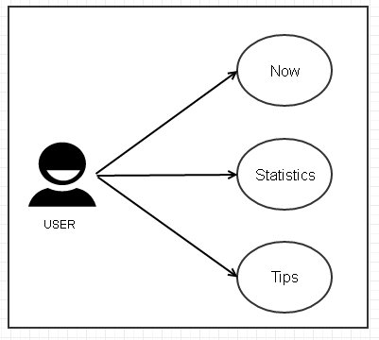 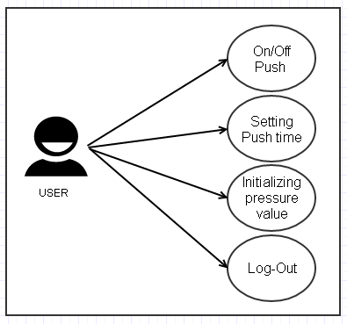

Fig. 20. Analysis Usecase

The another main function of this program is to offer analysis information using user’s posture data. And there are three sub functions in analysis part ’Now’, ’Statistics’ and ’Tips’. Analysis Usecase is shown in the Figure 20 and the Use Case’s descriptions are written in the table 11.

TABLE XI

THE DESCRIPTION OF ANALYSIS USECASE

Fig. 21. Setting Usecase

User could do four functions in the Setting page. Those are ’On/Off Push’, ’Setting Push time’, ’Ini- tializing pressure value’ and ’Log-Out’. This func- tions could help user customize program’s func- tions. Setting Usecase is shown in the Figure 21 and the Use Case’s descriptions are written in the table 12.

TABLE XII

THE DESCRIPTION OF SETTING USECASE

|  |  |
| --- | --- |
| Use Case | Description |
| On/Off Push | User could change the status of push alarm by On/Off. When user has urgent project meetint or needs to keep mobile phone silent, this function would be needed. |
| Setting Push time | User could set the time when user get the push alarm. The time has range from 1 to 10 minutes. For example, if user selects 2 minutes in this page(Default value is 1 minute)user would get push alarm when user keeps bad posture for 2 minutes. |
| Initializing pressure value | User could intialize pressure value in this page. The reason why user uses this function is that the actual user could be changed. So, when the actual user is changed the program initializes the pressure value making average value getting five times pressure values. |
| Log-Out | User could do Log-Out in this page. This function is required when user do not want to use this program or take out his/her own data to the database. |

.

|  |  |
| --- | --- |
| Use Case | Description |
| Now | User could see the two type of time in the ’Now’ part. First is the the time of user’s actual working hour. And the second is the time how much user keeps good posture and bad posture. And user could see the 3D feature reflecting user’s present posture. So, it could help user recognize their present posture visually. |
| Statistics | User could see the three type of analysing graphical data such as ’Day’, ’Week’ and ’Month’. The user’s data is saved in the database and the program analyzes that data and shows the graphical graph using that data. So, user could see the data distribution according to the selected period(User could select period by touching the upper tab). It meets the ’Statistics’ and ’Visualization’ requirements. |
| Tips | User could see the some videos about stretching good for posture correction. And some of exercises which are good for posture correction are recommended in this page. |

1. CONCLUSION

The conclusion goes here.

ACKNOWLEDGMENT

The authors would like to thank...

REFERENCES

[1] H. Kopka and P. W. Daly, *A Guide to LATEX*, 3rd ed. Harlow, England: Addison-Wesley, 1999.